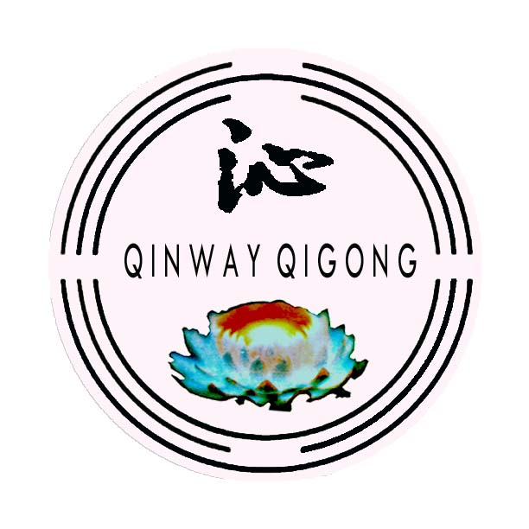
Remote Healing
with Grandmaster Qinyin

Qinway Qigong Institute, 320 Liliuokalani Ave. # 2105, Honolulu, HI 96815
Fax: 808-356-0632 E-mail: 930@qinway.org

Registration Form

Name |  | Sex |  |  | Age |  |  |  | Education
Address

Phone (D) |  | Phone (E) |  |  |  |  |  |  | E-mail
Job |  | Religion |  |  |  |  |  |  | Non-refund Fee $282.61
Major purpose
for healing
(major diseases)

Major family members & their health status

Training in Qigong, Taiji, Yoga, Reiki etc.
Your diet | - Both meat and vegetarian  - Vegetarian |  | Your bowel movements |  |  |  |  | - Irregular  - Regular. How often?
Your diet |  |  |  |  |  |  |  | - Dry stool  - Wet stool  - In between
Body Temperature | - Cold  - Neutral  - Hot |  | Weight |  |  |  |  | Sleep Quality |  |  | - Good  - average  - Bad
Body Temperature |  |  | Height |  |  |  |  |  |  |  | - Good  - average  - Bad
Are you on medication?
What medicine?
How did you hear about Qinway
Payment Method | $270 + $6 (shipping of Healing Tea) + $12.89 Hawaii Excise Tax = Total $288.89. You may pay by check, money order, Visa or Master Card. Please mail this form with a recent photo. We will contact you promptly to set up a remote healing plan upon receiving your materials.  Visa/MasterCard. Card #: Expiration Date:

